Check DB is not overloaded
LINK - https://portal.azure.com/32e5ebfd-31d2-47d4-b053-c50cfb62758f

Go to Azure > SQL Database > ModelSociety_PROD

There is a graph showing DB load. If it is less then 70% - DB is good.

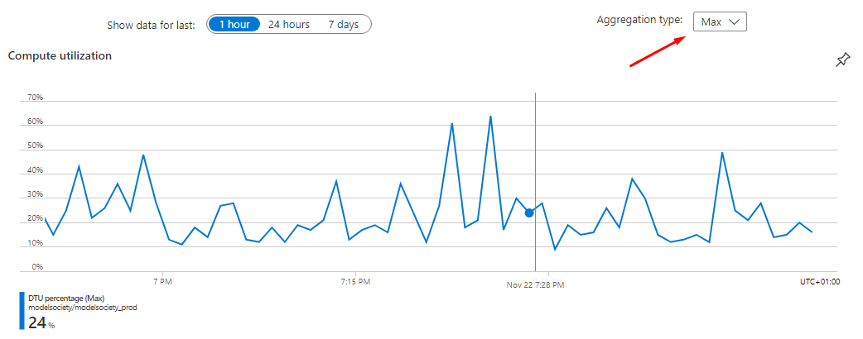

Check problems with processing images (WebJobs + queue)

Note: each manually delete message from queue = one unprocessed image and some garbage in the system. It needs to be resolved, but I have no tools for that at the moment.

First lets check queues for “posion” messages. They usually get stuck in a loop and causing constant load on the system.

Go to Azure > Storage accounts > modelsocietyimagecloud > Queues.

Visit each queue, which ends with “-poison” to see of there is something in there.

If the website is having some problems and there is a poison-queue with some messages in it - it might need to be cleaned up because there is a chance they stucked.

Note: messages in poison-queue is normal situation. It is part of retry mechanism. But unfortunately it has some problems now.

Cleaning up posion-messages
First, we need to stop WebJobs to make sure nobody is working with queues.

Go to Azure > App Services > ModelSocietyWebJobs - WebJobs.

Select WebJob in the list and click Stop.

Now go back to the posion-queue(s) and delete all messages in it. (clear queue/deque)

Note: don’t delete messages in non-posion queues. They are never a problem.

Now go back to the WebJobs and start it.

Restarting web app

Note: first check DB and WebJobs+queue before restarting. Problems with web app most likely caused by problems with other components.

Go to Azure > App Services > ModelSocietyWeb_PROD > Diagnose and solve problems > Advanced Application Restart.

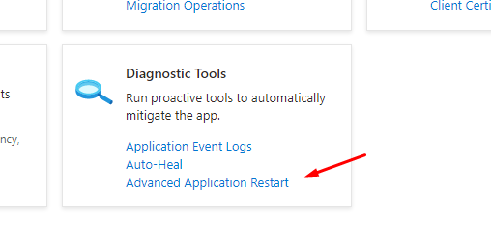

We have only one instance, it will be shown in the list. Click three dots menu on the right and select Restart.

CHECKING METRICS AFTER SERVER CHANGED TO 50%

Here are some metrics you may check if performance is bad:
- SQL server CPU load - https://portal.azure.com/#@themodelsocietygmail.onmicrosoft.com/resource/subscription[…]ql/servers/modelsociety/databases/ModelSociety_PROD/overview

There is a graph if you scroll a little bit. It has drop-down to select Average or Max.

- https://portal.azure.com/#@themodelsocietygmail.onmicrosoft.com/resource/subscription[…]rosoft.insights/components/ModelSocietyWeb-PROD-NEW/overview

Checkout Server response time graph. Normally average response time is like 400 ms. Right now it is 1.15 sec, but it is because warming-up and the graph shows average for some time period. Need to check "not affected" value in like 30 mins.
(edited)

